Crop Recommendation System
Samyak Jain¹, Aditya Garg² ,Ashutosh Saxena³ ,Manu Singh⁴

Computer Science Department, ABES Engineering College, Ghaziabad

Abstract- Agriculture is one of the significant employment measures for Indian farmers. There exists a routine problem that exists with most Indian farmers, i.e., they cannot make appropriate choices for a particular crop based on the type of soil. Productivity is deeply affected due to this. Precision agriculture solves this problem for them. This approach is distinguished by a farm-based soil database, crops offered by agricultural specialists, and the fulfilment of criteria like dirt through a dataset from a soil testing lab. The soil testing lab provides data from the system of recommendations. Then it will be utilized to gather data and create a band model. using a majority vote process. They apply an ANN with support vector machines students to accurately suggest a crop for site-specific factors and effectiveness.

- INTRODUCTION

India is a global agricultural powerhouse. About 60% of India’s population relies on agriculture for their living. The share of the agriculture sector in total Gross value added was 18.8% in FY 2021-
- The country's average monthly income per agricultural household was INR 10,218 in 2019. According to the 2011 census, each day around 2000 farmers gave up farming. Around 1100 farmers committed suicide accounting for 7% of total suicides within India. The farmers deploy obsolete and traditional methods for farming and crop selection. The unscientific ways of selecting crops to grow to result in the following problems: Low profits, Low productivity and Deteriorating soil quality. This further results in farmers leaving agriculture, higher migration rate toward cities, and high suicide rates. To overcome this problem and make farmers of India self-reliant, we propose a system as follows: To assist crop selection by considering soil factors namely Nitrogen, Potassium, and Phosphorus ratio, pH value, as well as environmental factors like relative humidity, rainfall, and temperature. The system is implemented using ML techniques which allow the system to update and improve on its own. The proposed system not only recommends native crops to the farmers but also exotic crops which suit the soil and environmental condition at a phase.

  - Definition:
Crop yield prediction is a crucial task for the decision-makers at the federal and provincial levels for fast decision- make. Accurate crop yield Predictive models can help farmers decide what to develop and when to manufacture. They are different crop yield forecasting techniques.

  - Scope:
The scope of the project is to determine the crop yield of a site by visualizing a data set with some essential or agricultural production-related characteristics such as temperature, humidity, rainfall, and yield. crop in previous years. To predict a continuous value, regression models are used.

- OBJECTIVE OF THE STUDY

Farming is one of the greatest wellsprings of procuring for Indians. However Indian ranchers buckle down in their fields, and their efficiency is undermined by regular variables. The reality can't be changed that natural variables are wild so the most effective way is to remove most from the field notwithstanding the organic elements.
One of the serious issues is soil corruption, which can be forestalled by developing the most reasonable harvest for the land. However, regardless of whether the rancher decides to grow a specific sort of harvest, then, at that point, the proper measurements of composts would help. Another serious issue is the bug which can be just treated through appropriate pesticides. This will help ranchers. The public authority conducts different tests in India which look at the items in the soil yet ranchers know nothing about how to manage the dirt experimental outcomes. Thus, Crop Recommendation System utilizes every one of the upsides of the tests and assists the ranchers with crop suggestions.

- LITERATURE REVIEW

Agriculture is a significant wellspring of occupation in India and Indian ranchers put their hearts and soul to take care of individuals. Ranchers for the most part manage harvests and composts. Thus, the Harvest proposal framework plans to serve Indian ranchers using the modules of Yield Suggestion. Crop suggestion has been a region that has been investigated a ton, however, every one of the frameworks changes given boundaries that are taken care of in the ML model. A large portion of the ML models utilizes Irregular Woodlands, some utilize Choice Trees, while others use Troupe techniques through the Greater part of Casting a ballot Component. The primary explanation can be crumbled information, yet the Harvest proposal framework gathered every one of the information from different sources and coordinated it to have a very much shaped dataset. A word reference-based arrangement is executed in the Harvest suggestion framework. The yield suggestion framework utilizes ISO 9001, and ISO 14001. The accompanying examined different examination papers about administrations given by the Harvest suggestion framework.

(Rajak et al. 951-952) i.e. paper [1] discusses crop expectations utilizing different students like SVM as a classifier, Guileless Bayes, Multi-facet perceptron (ANN), and Irregular Woods. The boundaries utilized for crop expectation are pH, profundity, water-holding limit, waste, and disintegration.

The standard underneath shows an illustration of the proposed suggestion framework.

    - pH is a mild alkaline
    - AND depth is above 90
    - AND water holding capacity is LOW
    - AND drainage is moderate
    - AND IF erosion is LOW
    - THEN PADDY

(Dighe et al. 476-480) i.e. paper [2] looked into CHAID, KNN, K- implies, Choice Tree, Brain Organization, Innocent Bayes, C4.5, Fellow, IBK, and SVM calculations and produced rules for the proposed framework. Taking into account different variables like the pH level of soil, the long stretch of development, the climate in the locale, temperature, the sort of soil, and so on factors were considered to choose the most extreme probably crops for the estate.

Area Identification, Information examination, and capacity, Comparative area discovery, and Suggestion age mo(Mokarrama and Arefin) i.e. paper [3] examined duel. The physiographic information base, Warm zone data set, Harvest developing period data set, crop creation rate data set, and occasional yield data set were utilized to get the last harvest.

(Gandge and Sandhya) i.e. paper [4] discusses Characteristic choice, Numerous Direct Relapses, and Choice Trees utilizing ID3, SVM, Brain Organizations, C4.5, K-implies, and KNN. The proposed framework comprises first the Determination of a horticultural field and afterwards, the Choice of a harvest recently planted, it takes input from the client and preprocesses it, then in the backend, there is characteristic determination followed by a characterization calculation of information and afterwards, the yield is suggested.

(Mishra et al.) i.e. paper [5] utilizes J48, Fellow Tree, LWL, and IBK calculation, first and foremost WEKA device is utilized, Chap tree showed the least exactness, however pruning the tree can limit the mistakes, and IBK gave great precision.

- Proposed Methodology

In our proposed model, we have taken into consideration both the soil quality as well as environmental factors. The soil factors taken into consideration are as follows:
- Nitrogen (Ratio)
- Phosphorus (Ratio)
- Potassium (Ratio)
- pH level
The environmental factors taken into consideration are as follows:
- Temperature (in oC)
- Rainfall (in mm)
- Relative Humidity (in %)
The soil and environmental factors both are taken into consideration because soil factors at a given place may favour a crop but environmental factors may not and vice-versa.
- The soil factors (Nitrogen ratio, Phosphorus ratio, etc.) are to be entered by the user.
- The existing segments deploy expensive IoT devices to assess the soil health indicators (i.e., Nitrogen, Phosphorus, Potassium value, pH, etc.) which makes it unfeasible.
- The use of expensive IoT devices to take readings makes it difficult to expand the model that can reach more people.
- To tackle this problem, our model proposes the use of soil health cards.
Under the soil health card started by the Government of India in 2015, more than 10 crores of soil health cards have been issued to Indian farmers. Soil health card contains the soil nutrient status of a farmer’s lands. It shows the nutrient status of the soil concerning 12 parameters.
- The ratio of Nitrogen, Phosphorus, and Potassium
- Sulfur values
- Zinc, Iron, Copper, Manganese, and Boron values
- pH, EC, OC (Physical Parameters)
From all these parameters our model uses the ratio of Nitrogen, Phosphorus, and Potassium values, and the pH of the soil.
To know the environmental factors that are rainfall, temperature, and humidity our model makes use of weather API.
The third factor which our model uses is supply and demand data.
Depending on the demand data of crop commodities mainly rice, wheat, maize, cereals, pulses, food grains, oilseeds, and sugarcane
over five years. We will produce the demand in upcoming years.

TABLE I
GAP ANALYSIS

Sr. N  o. | Name of Researcher, Year of Publication | Paper Title | Parameters Used/ Database Used | Methodology Adopted/ Modules Used
1. | Rajak et al., 2017 | Crop Recommendation System to Maximize Crop Yield Using Machine Learning Technique. | pH, depth, water holding capacity, drainage, erosion. | SVM is used as a classifier, Naive Bayes, Multilayer perceptron (ANN) and  Random Forest.
2. | Dighe et al, 2018 | Crop Recommendation System for Precision Agriculture. | The pH level of soil, the month of cultivation, the weather in the region, temperature,  type of soil | CHAID, KNN,  K-means, Decision Tree, Neural Network, Naïve Bayes, C4.5, LAD, IBK  and SVM
3. | Mokarra ma and Arefin, 2017 | RSF: A  Recommendation System for Farmers | Physiographic c database, Thermal zone database, Crop growing period database, crop production rate database and seasonal crop database. | Location Detection, Data analysis and storage, Similar location detection and Recommendation n generation.
4. | Gandge and Sandhya  , 2017 | A study on various data mining techniques for crop yield prediction. | Agricultural field, Crop previously planted. | Attribute selection, Multiple Linear Regression, and Decision Tree using ID3.

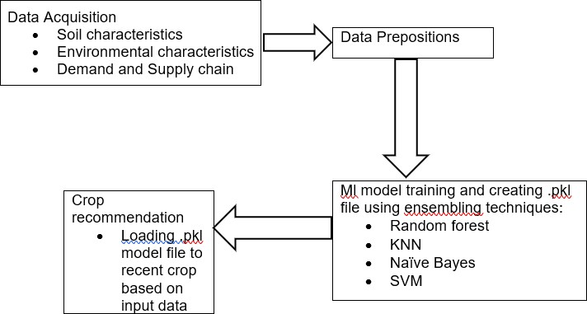
Fig 1. Flowchart

The following section discusses how the “Crop Recommendation System” can be implemented.
The Crop Recommendation system can be implemented in four steps as discussed below:

A: Data Acquisition

The dataset can be acquired from Kaggle.

B: Values Input

Users are expected to input the site-specific parameters like N, P, and K (all of them in %), temperature (in °C), relative humidity (in
%), rainfall (in mm) and pH.

C: ML Model Training and creating .pkl file

The recommendation system is based on the ensemble model with a majority voting technique. The constituent models are:

- SVM
- Random Forest
- Naive Bayes
- kNN After the model is trained, a .pkl file is created.

D: Crop Recommendation

.pkl file is loaded to recommend the crop based on input.
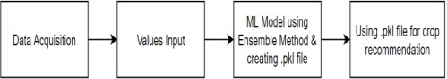

Fig 2. Methodology for Crop Recommendation

TABLE II
ACCURACY DATA

 | ACCURACY | LOSS
TRAINING | 0.9699 | 0.0712
VALIDATION | 0.9520 | 0.4681

- CONCLUSION AND RESULTS
The proposed model for the "Crop Recommendation System" can be decided from different angles. For the yield

suggestion, since the ML model, is utilized to foresee the yield which would be most appropriate according to the site-explicit boundaries, so here precision score assists with telling how powerful the arrangement is. A gathering model utilizing a larger part casting a ballot method was utilized. The students are Credulous Bayes, kNN, SVM, and Irregular Timberland. The exactness Score emerged to be 96.44%. The ideal exactness was >= 90%, yet the ML model can accomplish 96.44%, subsequently, it's calculable. Here, the presentation metric is preparing and approval exactness, and preparing and approval misfortune which is displayed underneath.

- Our model promotes and recommends that Indian farmers grow crops that suit their geographical and soil factors.
- Our model helps the farmers better choose a crop by considering the factors that are generally not considered while using traditional methods.
- This results in less dependence on the import of exclusive crops.
- This helps to increase the income of farmers and make India self-sufficient.

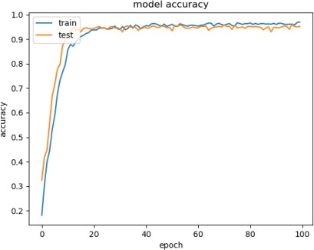
Fig 3. Model Accuracy vs Epochs
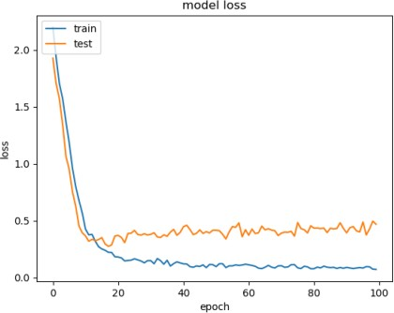
Fig 4. Model Loss vs Epochs

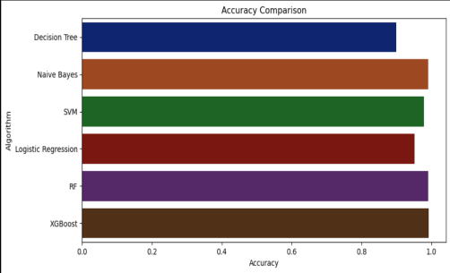HTC), Dhaka, Bangladesh, 2017, pp. 843-850, doi: 10.1109/R10-HTC.2017.8289086.

[9] M. Pawar and G. Chillarge, "Soil Toxicity Prediction and Recommendation System Using Data Mining In Precision Agriculture," 2018 3rd International Conference for Convergence in Technology (I2CT), Pune, India, 2018, pp. 1-5, doi: 10.1109/I2CT.2018.8529754.

Fig 5. Accuracy Comparison of different models

  - Figure 3 is showing the accuracy of different models compared to epochs (An epoch is a specific point in time used as a reference for a particular period.)
  - Figure 4 is showing the loss of a particular model to epochs.
  - Figure 5 is showing the accuracy of different models.

REFERENCES

- Rajak, Rohit Kumar, et al. “Crop Recommendation System to Maximize Crop Yield using Machine Learning Technique.” International Research Journal of Engineering and Technology (IRJET), vol. 04, no. 12, 2017, pp. 951-952. IRJET

- Dighe, Deepti, et al. “Crop Recommendation System for Precision Agriculture.” IRJET, vol. 05, no. 11, 2018, pp. 476-480. IRJET

- Mokarrama, Miftahul Jannat, and Mohammad Shamsul Arefin. “RSF: A Recommendation System for Farmers.” Region 10 Humanitarian Technology Conference, vol. 2, no. 17, 2017

- Gandge, Yogesh, and Sandhya. “A study on various data mining techniques for crop yield prediction.” IEEE Xplore, 2017. IEEE Xplore

- Mishra, Shruti, et al. Use of data mining in crop yield prediction. 2018. ResearchGate

- S. K. S. Raja, R. Rishi, E. Sundaresan and V. Srijit, "Demand-based crop recommender system for farmers," 2017 IEEE Technological Innovations in ICT for Agriculture and Rural Development (TIAR), Chennai, India, 2017, pp. 194-199, doi: 10.1109/TIAR.2017.8273714.

- G. Chauhan and A. Chaudhary, "Crop Recommendation System using Machine Learning Algorithms," 2021 10th International Conference on System Modeling & Advancement in Research Trends (SMART), MORADABAD, India, 2021, pp. 109-112, doi: 10.1109/SMART52563.2021.9676210.

- M. J. Mokarrama and M. S. Arefin, "RSF: A recommendation system for farmers," 2017 IEEE Region 10 Humanitarian Technology Conference (R10-

- S. Vaishnavi., M. Shobana., R. Sabitha. and S. Karthik., "Agricultural Crop Recommendations based on Productivity and Season," 2021 7th International Conference on Advanced Computing and Communication Systems (ICACCS), Coimbatore, India, 2021, pp. 883-886, doi: 10.1109/ICACCS51430.2021.9441736.

- S. Chhikara and N. Kundu, "Machine Learning based Smart Crop Recommender and Yield Predictor," 2022 International Conference on Computing, Communication, and Intelligent Systems (ICCCIS), Greater Noida, India, 2022, pp. 474-478, doi: 10.1109/ICCCIS56430.2022.10037678.

- T. K. Mishra, S. K. Mishra, K. J. Sai, B. S. Alekhya and A. R. Nishith, "Crop Recommendation System using KNN and Random Forest considering Indian Data set," 2021 19th OITS International Conference on Information Technology (OCIT), Bhubaneswar, India, 2021, pp. 308-312, doi: 10.1109/OCIT53463.2021.00068.

- “Web-Based Recommendation System for Farmers” by Kiran Shinde, Jerrin Andrei, AmeyOke (2014)

- “Crop Recommendation System to Maximize Crop Yield using Machine Learning Technique” by Rohit Kumar Rajak, Ankit Pawar, Mitalee Pendke, Pooja Shinde, Suresh Rathod, Avinash Devare (2017) “Automated crop prediction based on efficient soil nutrient estimation using a sensor network” by Lokesh. K, Shakti. J,Sneha Wilson, Tharini. M.S (2016)

- “Crop Recommendation System to Maximize Crop Yield in Ramtek region using Machine Learning” by D. AnanthaReddy, Bhagyashri Dadore, and Aarti Watekar (2019)

